Big Data Infrastructure and Technology Essay
Name: Wilbert Chandra
NIM: 2602113666

- Analysis of the ELT Processes are
- Extract & Load: This phase involves pulling data from various sources and loading it directly into the staging tables of the target MPP database. This approach takes advantage of the MPP database's capabilities to handle large volumes of data efficiently.
- Transform: Once the data is loaded into the staging tables, it undergoes transformation within the MPP database. This transformation process includes data cleaning, normalization, aggregation, and other operations to convert the raw data into a useful format. The transformed data is then stored in the final tables, ready for analysis and reporting.
- Choose one case or problem and use the ELT process to express and perform data operation for your case.
Case: Healthcare Patient Data Integration for Predictive Analysis
Goals: Integrate patient data from various sources to predict patient readmission rates within 30 days of discharge. This involves extracting data from different systems, loading it into a data warehouse, and transforming it for analysis.
Steps:
- Extract & Load:
  - Extract raw data from the EHR system, hospital admission system, and external lab results files.
  - Load the extracted data into the staging tables in the MPP database.
- Transform:
  - Transform the raw data by joining relevant tables and calculating necessary risk factors.
  - Store the transformed data in the final tables for predictive analysis.

- Design a simple cloud architecture for a Smart Car manufacturer that utilizes the cloud for data collection and improving the overall features of their products via OTA updates.
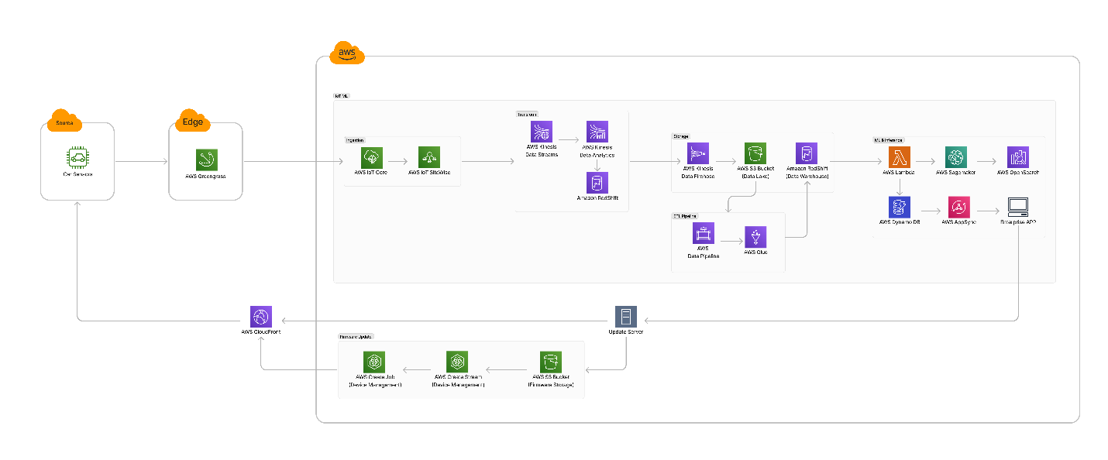
https://www.figma.com/board/6lZPlkuAe9ZdIbp3ttEc0F/UAS-Big-Data?node-id=0-1&t=yKg878vNJ9I0JqJq-1
Flow of Data and Updates
- Data Collection: IoT devices in the car collect and send data to the IoT Gateway.
- Data Transmission: The IoT Gateway sends data to the cloud via the Data Ingestion Service.
- Data Processing and Storage: Data is stored in the Data Lake, processed by ETL pipelines, and stored in the Data Warehouse.
- Analytics and Machine Learning: Processed data is analyzed, and ML models are trained to gain insights and predict issues.
- OTA Updates: Update Server prepares OTA updates, distributed globally via CDN, and securely delivered to smart cars.
- Security and Compliance: IAM, encryption, and compliance monitoring ensure data and system security.

- A company providing chatbot services using generative AI currently accepts input only in text format. They plan to add a feature allowing users to input images for analysis based on user requests. Please select the most appropriate AWS services for this case and describe their implementation with respect to the following aspects:
  - Cost optimization
  - Reliability
Answer:
- Amazon Rekognition for image analysis.
- AWS Lambda for serverless computing.
- Amazon S3 for storing images.
- Amazon CloudFront for content delivery.
- AWS Step Functions for workflow orchestration.
- Amazon CloudWatch for monitoring and logging.
Reason:

AWS Service | Cost Optimization | Reliability
Amazon Rekognition | Pay per image analyzed.  Use custom labels to reduce unnecessary processing. | High availability and automatic scaling.  Built-in fault tolerance.
AWS Lambda | Pay only for execution time and requests.  Optimize memory allocation and execution time.  Utilize the free tier. | Automatic scaling.  High availability across multiple Availability Zones.  Built-in fault tolerance.
Amazon S3 | Use lifecycle policies to move data to cheaper storage classes.  Leverage the free tier (5GB). | 11 9's durability and 99.99% availability.  Enable versioning and cross-region replication for reliability.
Amazon CloudFront | Cache frequently accessed images to reduce S3 requests.  Lower data transfer costs. | Global network of edge locations.  High availability and low latency.  Automatic failure redirection.
AWS Step Functions | Efficiently orchestrate workflows.  Prevent unnecessary service executions. | Reliable execution with automatic retries.  Seamless integration with other AWS services.
Amazon CloudWatch | Monitor usage and set up cost alarms.  Utilize the free tier (10 custom metrics, 5GB log data). | Comprehensive monitoring and logging.  Automatic recovery actions with set alarms.

